Diagram Example:

Corrugated Boxes

| September-20 |

**Document Overview**

**Documentation Goals**

This documentation is intended to provide the user with an example of the ***Corrugated Boxes – CORRCASE*** documentation*.*

**Table of Contents**

**Corrugated Boxes** 2

Order Quantity = 360 2

B-3-1 BOL SCREEN 2

B-2-1 RELEASE SCREEN 2

ESTIMATING PAGE 3 2

DIAGRAM 2

FINISHED GOODS RECEIPTS 2

# **Corrugated Boxes**

## Order Quantity = 360

### B-3-1 BOL SCREEN



### B-2-1 RELEASE SCREEN



### ESTIMATING PAGE 3

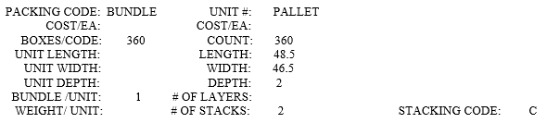

### DIAGRAM

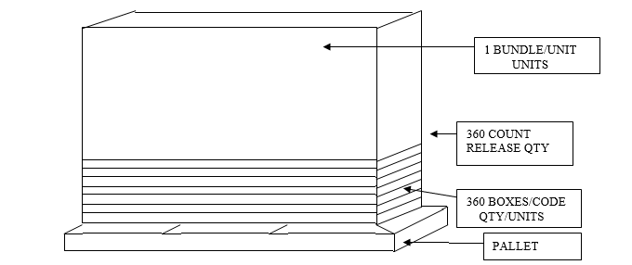

### FINISHED GOODS RECEIPTS

